Pune District Education Association’s
Seth Govind Raghunath Sable College of Pharmacy, Saswad
Activity Report
Title of the event: Guest lecture on “Indian Religious Festivals – Re-Learning Nature Conservation Values to stop Wildlife Crimes”
Name of activity: Environmental awareness week
Date and Day: 09/02/2024 Friday Time: 02:30 pm to 05:00pm
Wildlife Conservation can be defined as preventing wildlife from uneven killing and poaching. It also involves the practice of making people aware by telling them about the importance of wildlife. Wildlife Conservation is very important to maintain the food chain and ecosystem balance. In this view a guest lecture on the topic “Indian religious festivals – Re-learning nature conservation value to stop wildlife crimes” has been organized in the college on 09th February 2024 at 02:30 pm. Dr. Suruchi Pande Vice chair Ela Foundation Pune gave valuable guidance on our immediate responsibility to safeguard the ecosystem's natural splendor and to develop a system of coexistence with every living creature on earth. While the world's nations must be very specific in terms of wildlife conservation, the amount of wildlife is diminishing day by day. Developing protective areas such as national parks, wildlife sanctuaries to protect the animals in their natural habitat. The endangered and vulnerable species can be kept in captivity in places such as zoos and bred to increase their population. The cutting of forests should be strictly prohibited. Our faculty members and students are greatly benefited and are sensitized from her views and guidelines. The program ended with a vote of thanks by Mr. Nilesh Bhosale. The activity conducted under the guidance of Principal Dr. R.S. Chavan.

Mrs.J.V.Shinde Dr. Rajashree Chavan

Guest Lecture 9th February 2024
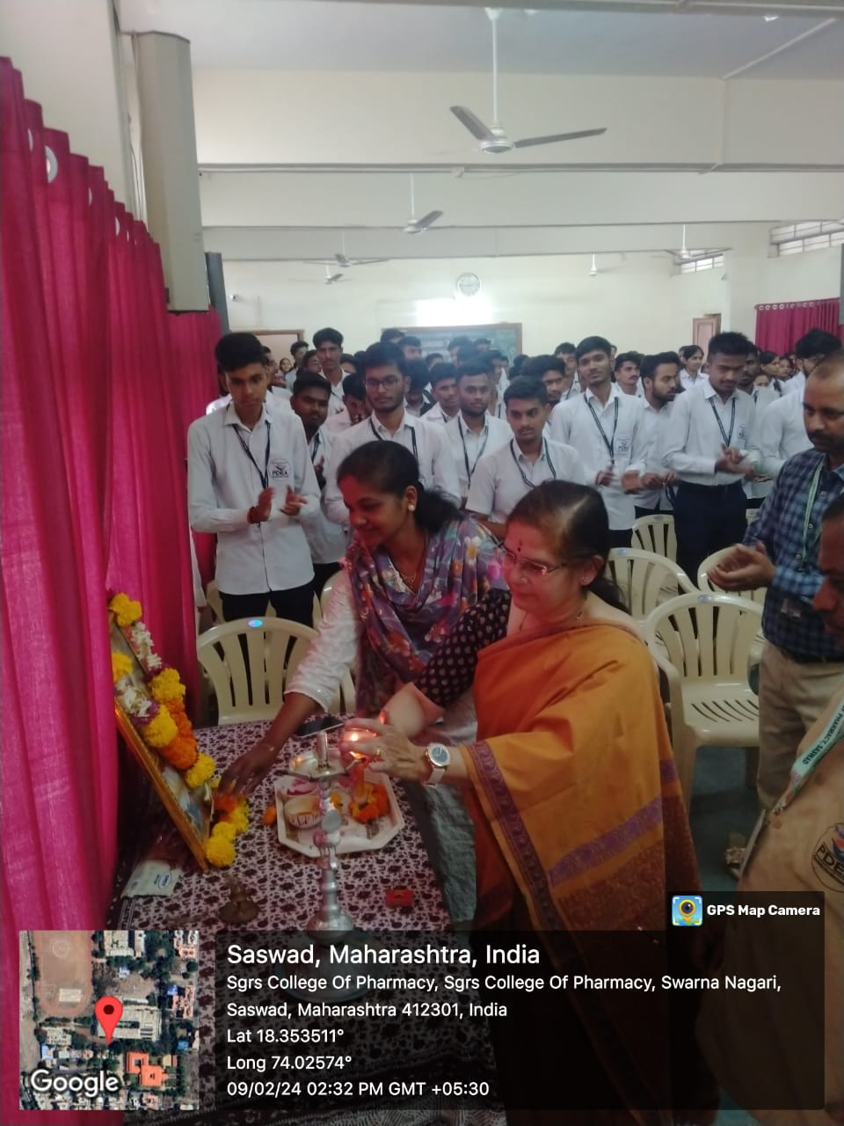

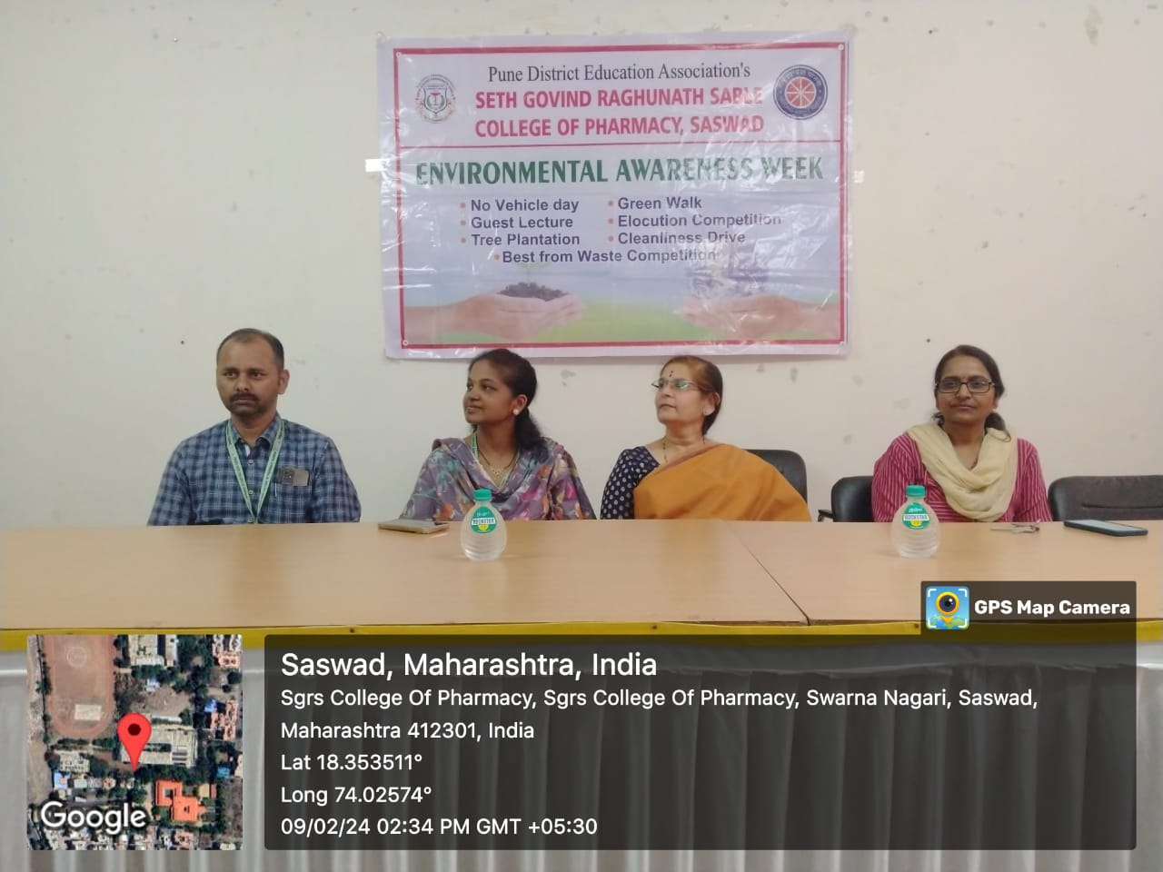

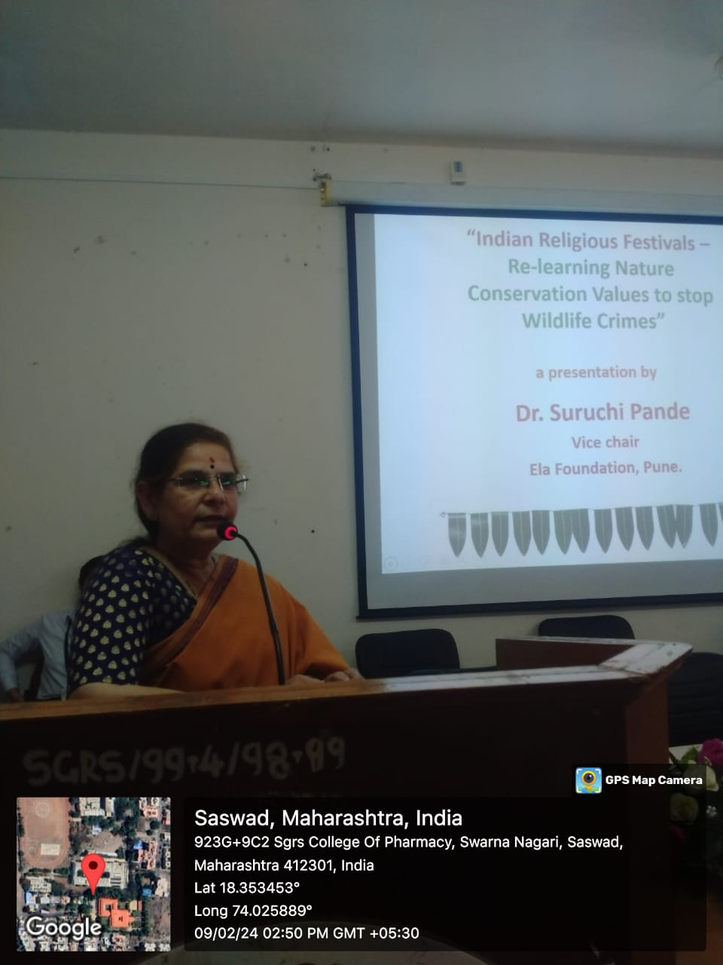
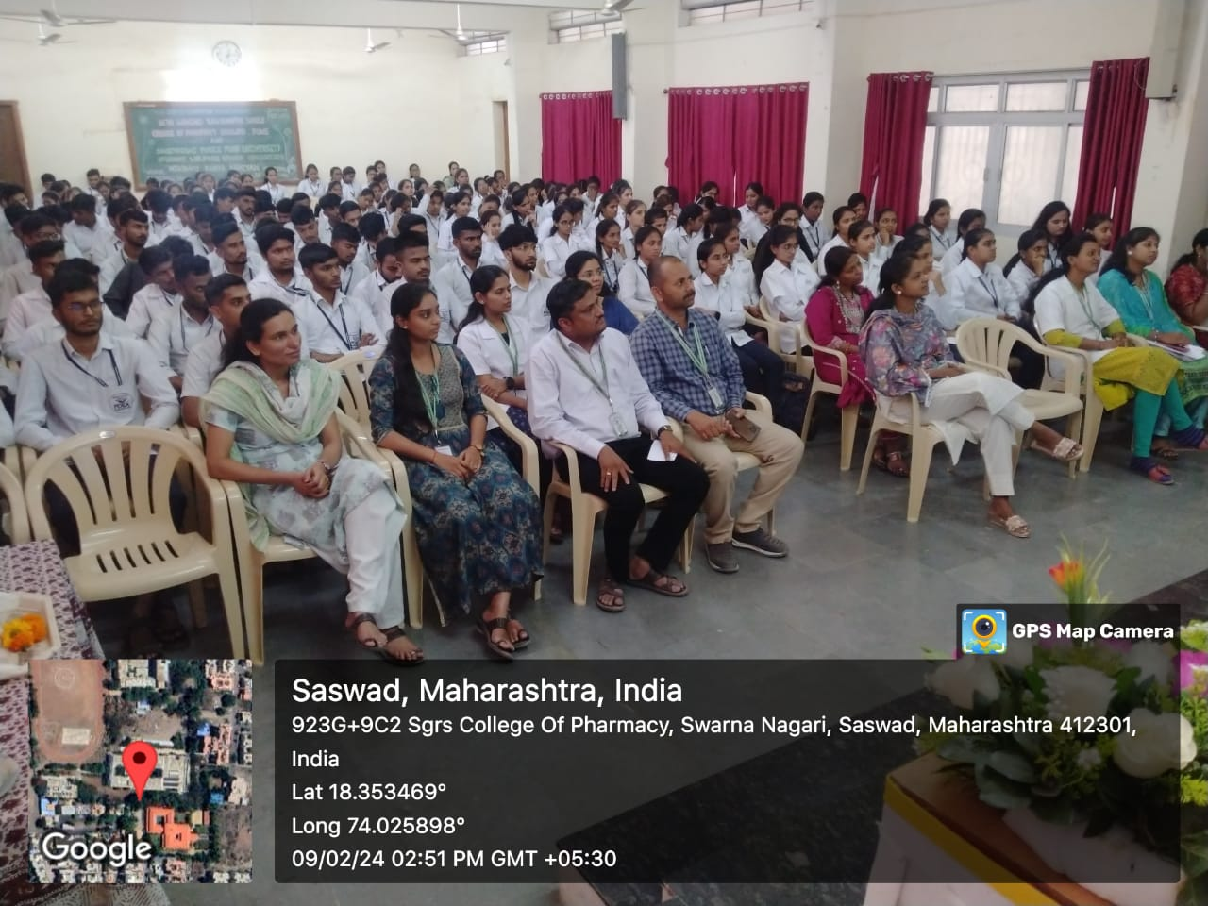

Dr. Rajashree Chavan
Principal

